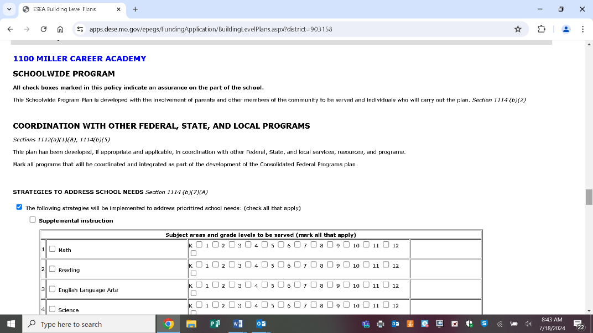****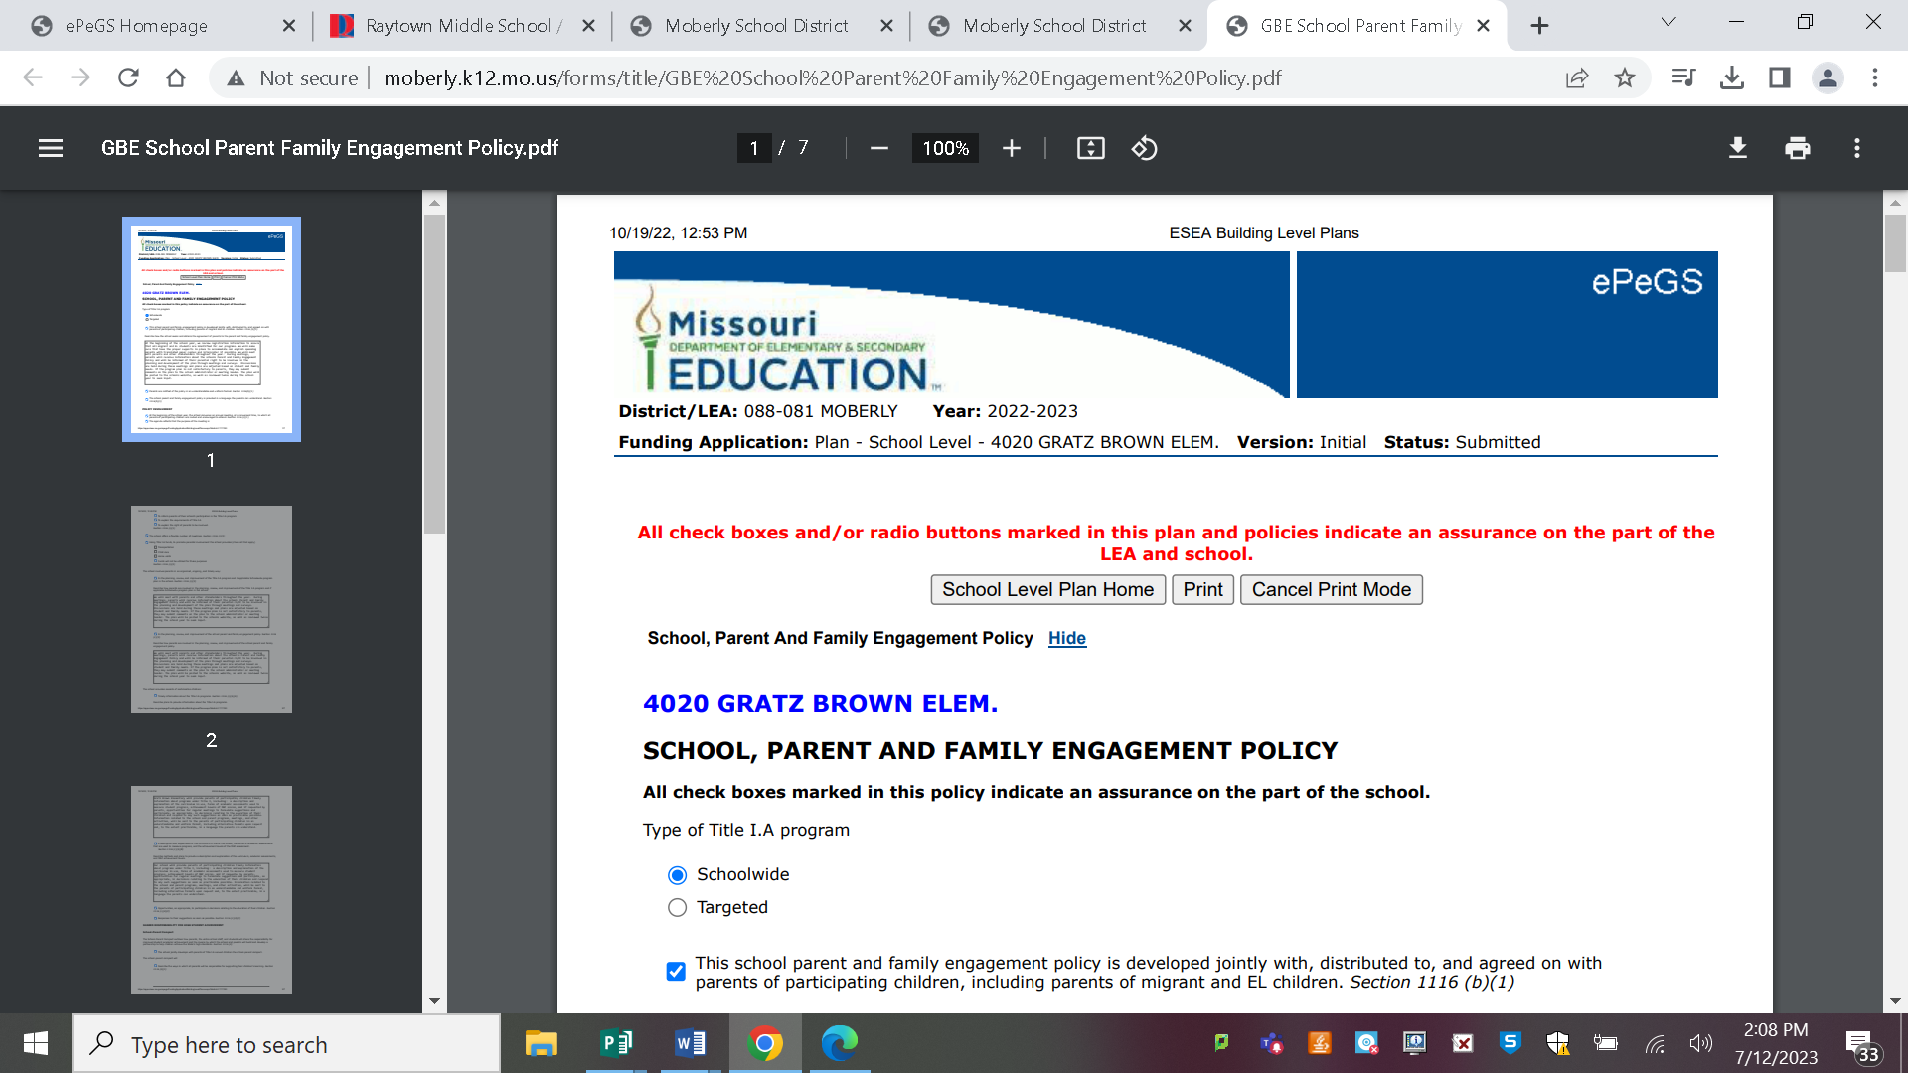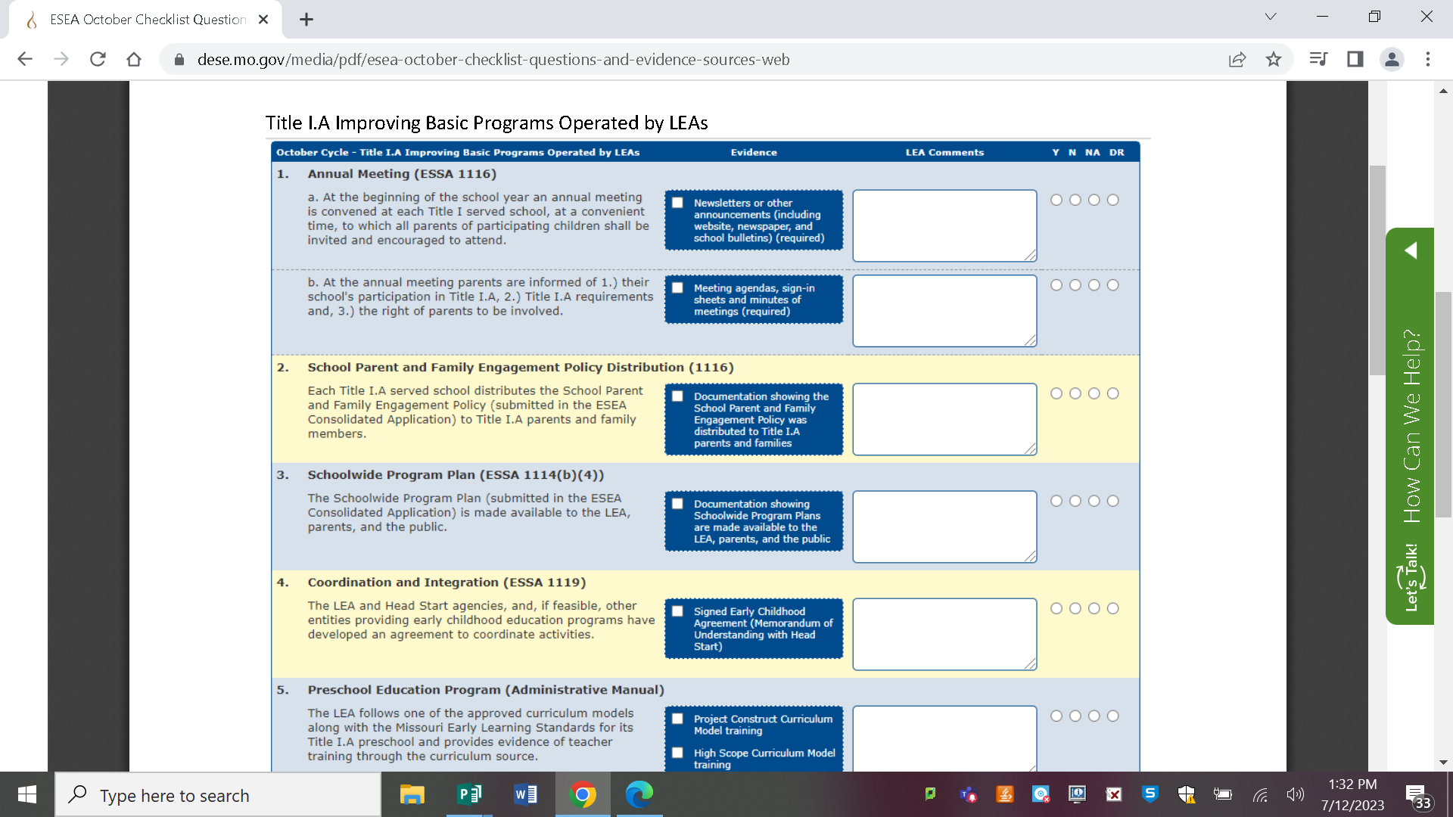

**SLPS Title I.A Annual Informational Meeting**

**SLPS Title I.A Annual Informational Meeting**

Each Family, Staff Member, and Community Partner Gets One. (soft/hard copies)

Where Am I Accessible?